**Marking Policy**

At Hazel Cottage School we want all pupils to make good or better progress and develop positive attitudes to their learning. Our marking policy is designed to support this.

**Aims**

Where appropriate, we give feedback and mark pupils’ work in order to:

* Show pupils that we value their work and encourage them to do the same
* Boost self-esteem and aspirations through use of praise and encouragement
* Give pupils specific information on the extent to which they have achieved the learning objective and how to further improve their work (Total Communication approach)
* Check whether pupils have achieved the learning objective, identify misconceptions and use this information to inform future planning
* Share expectations (Total Communication approach)
* Where appropriate, promote self-assessment – through modelling and questioning we support pupils in recognising their achievements and where they can make further improvements

**Principles**

* Feedback and marking should be meaningful to pupils, teaching staff and parents.
* Oral/Visual feedback should be given during the lesson allowing pupils to think about their learning and make improvements to their work there and then. This is often the most appropriate form of feedback for our pupils. Oral/Visual feedback is particularly important for our pupils with language and communication difficulties who benefit from immediate, simple forms of feedback to promote an understanding of their achievements.
* Lots of praise and encouragement will be given to pupils during activities and when activities have been completed.
* Celebration assemblies allows us to celebrate pupils’ efforts and achievements.
* The date and the learning outcome will be written on every piece of work either by the pupil or member of teaching staff.
* Marking should be done as soon after the lesson as possible. Pupils will be given time to look at their marked work and reflect upon their learning. When appropriate, pupils will be given time to make further improvements/complete corrections.
* As pupils become more confident they will be encouraged to assess their own work and comment on the work of others, leading up to peer assessment.

Where appropriate all teachers follow a **'Progress in Pink'** and **'Green for Growth'** system.

Where learning outcomes have been met and progress has been made, this will be highlighted/

commented on in pink. Next steps will be highlighted/ commented on in green. Teachers may

choose to reinforce verbal feedback with a pink object of reference if appropriate for their class.

This system will also be used when annotating photographs and Learning Journals

**Annotation**

A key part of ensuring consistency across the school is in the accurate and useful annotation of

work including photographs. Annotation should include the context of the evidence, the level of

types of support given, it may include the frequency that the target was met and the level of

interaction that the pupil demonstrated.

Folder/Book work may also be annotated with a Gold Star. This will highlight where pupils have made clear progress towards a specific, individual target (EHCP/IEP). For example, if an IEP target is to focus on letter formation and progress towards this target is clearly evident then the adult will use the gold star to highlight the progress. This may be evident in the very next piece of work or in future work.

Teachers will use a traffic light system to assess pupils work- using Hazel Cottage’s Budding, Growing, Blossoming approach.

*Teachers must evidence 3 pieces of work, per pupil per week, as a minimum- SOLAR*

*Teachers/Support staff must evidence 3 achievements, per child per week, as a minimum - Evidence for Learning.*

**Self-Assessment**

Where appropriate, pupils will be encouraged to use self-assessment as a form of marking their own

work. They will be encouraged to reflect on their own development and progress, comparing

their current work with that produced previously, their own personal targets and lesson

objectives. Showing examples of work that do and do not meet the success criteria can help

pupils to understand more fully what is required and to reflect on the things they need to do in

order to improve.

Pupils will be encouraged to use a widget symbol system when completing self-assessment. They will be encouraged to colour or circle the appropriate part of the traffic light to assess their work. (see attached traffic light visual aid). Where appropriate pupils will be encouraged to generate a target following on from their self-assessment.

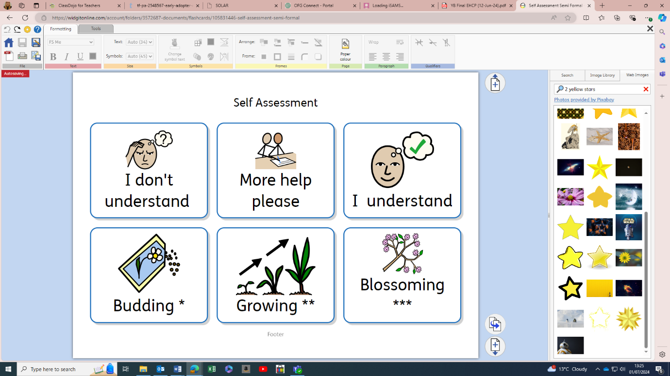

|  |  |
| --- | --- |
| **Hazel Cottage Standard Annotation codes for Early Years, KS1 & KS2** | |
| I | **Independent Work** |
| **VP** | **Verbal/Visual Prompt** |
| **GP** | **Gestural Prompt** |
| **PP** | **Physical Prompt** |
| **GQ** | **Guided questioning** |
| **CO** | **Choice of** |
| **VF** | **Verbal Feedback** |
| **SC** | **Self-Correction**  Pupil has made their own corrections in green pen. |
| **CT** | **Corrected together**  Corrected with an adult- in green pen. |

* *Annotation codes will be on Evidence for Learning hashtags #*
* *Annotation Codes can be added to evidence comments section on SOLAR.*
* *Annotation codes to be added to pupil’s work in folders and books*

|  |  |
| --- | --- |
| **Hazel Cottage Marking codes**  **– where appropriate within different curriculum pathways** | |
| **CL** | **Capital Letter** |
| **FS** | **Full Stop** |
| **Sp** | **Spelling Mistake** |
| **L** | **Start a new line** |
| **//** | **Start a new paragraph** |
| **Ww** | **Wrong word used (there, their)** |
| **P** | **Punctuation** |
| **|||** | **Finger space** |

|  |  |
| --- | --- |
| **Policy Number** | **1.0** |
| **Review Date** | **July 2026** |

**Document History**

|  |  |  |  |
| --- | --- | --- | --- |
| **Version** | **Comments/amendments** | **Name** | **Date** |
| 1.0 | First Version | Laura Kitching | July 2024 |
|  |  |  |  |
|  |  |  |  |
|  |  |  |  |
|  |  |  |  |
|  |  |  |  |
|  |  |  |  |
|  |  |  |  |
|  |  |  |  |
|  |  |  |  |
|  |  |  |  |
|  |  |  |  |